AFRICAN LEADERSHIP UNIVERSITY
Introduction to Blockchain Development
Design and Implementation of a Blockchain-Based Library Book Lending Tracker
Technical Report
Student: Aman Abraha Kasa
Course: Introduction to Blockchain Development
Institution: African Leadership University
Assignment: Individual Assignment 1
Date: September 2026
GitHub: Github-Repo[FA:1]
Demo Video: Demo-Vid(Youtube)

Table of Contents
1 Introduction 3
1.1 Background 3
1.2 Project Objective 3
1.3 Scope 3
1.4 Functional Requirements 3
2 System Architecture and Design Diagram 4
3 Blockchain Implementation 5
3.1 Block Structure 5
3.2 Genesis Block 6
3.3 Block Creation and Linking 6
4 Registry Management 7
4.1 Book and Member Registries 8
4.2 Registry Validation 8
5 Security Mechanisms 8
5.1 SHA-256 Hashing and Hash Linking 9
5.2 Digital Signatures and Key Management 9
5.3 Security Limitations 10
6 Data Persistence 10
7 Core Operations, Validation and Tamper Detection 11
7.1 Borrow, Return and View Records 11
7.2 Chain Validation 12
7.3 Tamper Demonstration 13
8 Error Handling and Data Validation 13
9 Testing and Results 14
10 Screenshots of Application Execution 15
11 Challenges Encountered and Solutions 18
11.1 Variable-length signatures in a fixed-size field 18
11.2 Choosing a persistence format 18
11.3 Showing tamper detection without weakening security 18
11.4 POSIX functions under strict C11 19
11.5 Unsafe string copy found during review 19
12 Discussion 19
13 Conclusion 19
14 References 20
Appendix A — Selected Code 21
Appendix B — Implementation Traceability 22

1 Introduction

1.1 Background
A library lending log records who borrowed which book and when it came back. In most libraries this log is a database table or a paper register, and whoever controls it can change it afterwards: a lost book can quietly be marked "returned", or a borrower can dispute an entry, and nothing in the log shows which version is authentic. An append-only ledger fixes this by linking each record to the one before it with a cryptographic hash and signing it with a private key. Editing a past record then breaks the hash, the link to the next record or the signature. The goal is not to stop anyone editing the file, which is impossible for a local file, but to make every edit detectable the next time the ledger is checked.

1.2 Project Objective
The project implements a command-line Library Lending Chain in C. Every borrow and return becomes a block in a linked-list blockchain. Each block is hashed with SHA-256, linked to the previous block through previous_hash, and signed with an ECDSA (NIST P-256) key using OpenSSL 3. Book and member IDs are checked against file-based registries before any block is created. The chain is saved to a text file after every change and re-verified every time the program starts. The source code is in individual-assignment_FA-1/ of the GitHub repository aman-kasa/blockchain-coursework, split into six modules: main.c, registry.c, blockchain.c, crypto.c, persistence.c and cli.c.

1.3 Scope
In scope: loading books.txt and members.txt; a genesis block; signed BORROWED and RETURNED blocks; rejecting invalid IDs, double borrows and invalid returns; full chain validation at start-up, on demand and before every write; saving and reloading the chain from a file; and a persistent ECDSA key pair.
Out of scope: networking, peer nodes, consensus and mining, since this is a single process on one machine; user accounts, login and role-based access control (section 5.3); and automatic OVERDUE records, because the brief defines no due-date rule for them.

1.4 Functional Requirements
Table 1 maps each requirement in the brief to the code that implements it. The status column reflects what was verified by reading the code and running the program, not what the project's own documentation claims.
Table 1. Assignment requirements mapped to the implementation
Requirement (brief) | Implementation | File → function | Status
Blockchain of lending records | Linked list of Block structs (head, tail, length) | blockchain.h → Block, Blockchain | Met
Book / member registries from file | Loaded into Book[256] / Member[256] at start-up | registry.c → registry_load() | Met
Error if a registry file is missing or empty | Specific ERROR: message, then FATAL, exit code 1 | registry.c; main.c → main() | Met
Reject unknown book / member IDs | ERROR: Book or Member not found | registry_find_book(), registry_find_member() | Met
Genesis: index 0, 64-zero previous_hash | Created on first run, hashed and signed | blockchain_create_genesis() | Met
SHA-256 links blocks | EVP_Digest over 8 fields incl. previous_hash | crypto_sha256_hex(), seal_block() | Met (note A)
Digital signatures | ECDSA P-256 over each block's hash | crypto_sign_hash(), crypto_verify_hash() | Met
Borrow / Return rules | ID, loan-state and chain-integrity checks before writing | blockchain_borrow(), blockchain_return() | Met
Validate chain (hash + link) | Both checks, plus index order and signature | blockchain_validate() | Met
View records incl. signature validity | All fields, hashes and a VALID/INVALID status per block | cli.c → print_records() | Met (note B)
Tamper detection; persistence; CLI | Text file data/chain.txt; 9 commands | persistence.c; cli.c → cli_run() | Met
Action OVERDUE | Fits in action[10] but is never created | — | Not implemented
Objective: user authentication and access control | One installation-wide signing key; no login or roles | crypto.c | Partial (5.3)

Note A — The brief describes hash as a hash of "all the above fields" and says to "sign it, compute its hash". The code does the reverse: it hashes the eight data fields (everything except signature and hash) and then signs that hash. The signature therefore still covers all the block's data.
Note B — view records checks each signature against the block's stored hash, so a block whose data was edited but whose stored hash was not changed still shows signature=VALID there. validate chain recomputes the hash and does catch it (section 7).

2 System Architecture and Design Diagram
Each of the six modules owns one concern and exposes it through a header file: main.c runs the start-up sequence, registry.c handles the registries, blockchain.c holds the chain rules and validation, crypto.c wraps every OpenSSL call, persistence.c owns the file format, and cli.c runs the command loop. Figure 1 is the system design diagram. It shows the registry path on the left, the borrow/return write path in the centre, and key handling, storage and verification on the right.
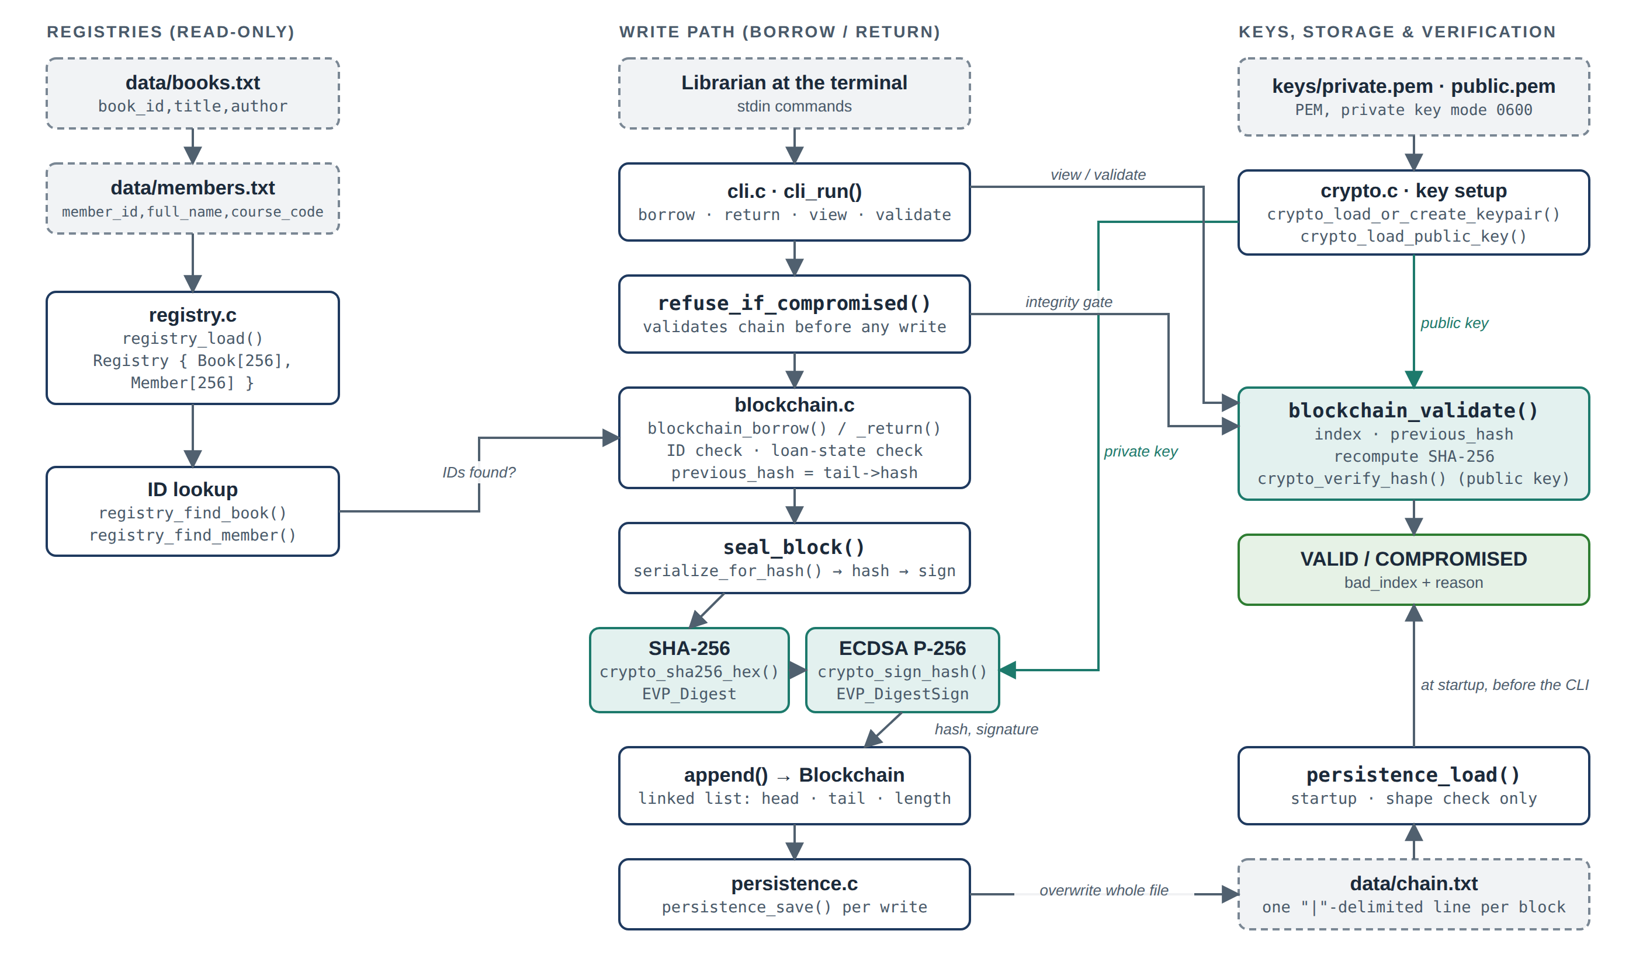
Figure 1. System design diagram: registries, lending (write) path, cryptography, storage and verification
Data flow. registry_load() reads both files once into a read-only Registry. A borrow or return passes through refuse_if_compromised(), which runs blockchain_validate() and refuses to write if the chain is already invalid. The business rules in blockchain.c then check the IDs and loan state and fill in the new block. seal_block() hashes and signs it, append() links it to the tail, and persistence_save() rewrites data/chain.txt. At start-up, persistence_load() rebuilds the chain and blockchain_validate() checks it, using the public key, before the first command is accepted.

3 Blockchain Implementation

3.1 Block Structure
struct Block in blockchain.h has the ten fields from the brief. Their sizes come from named constants (BOOK_ID_LEN 20, BOOK_TITLE_LEN 80, MEMBER_NAME_LEN 50, ACTION_LEN 10, HASH_HEX_LEN 65, MAX_SIGNATURE_LEN 72). Two extra fields exist only in memory: next for the linked list, and sig_len for the actual signature length (Challenge 11.1).
Table 2. Fields of struct Block
Field | Type | Purpose and source
index | int | Position in the chain (0 = genesis); set to chain->length when created
timestamp | time_t | Creation time, from time(NULL)
book_id, book_title | char[20], char[80] | Copied from the registry on borrow, and from the matching BORROWED block on return
member_id, member_name | char[20], char[50] | Same as above (the brief spells it Member_name; the code uses member_name)
action | char[10] | GENESIS, BORROWED or RETURNED
previous_hash | char[65] | Hex SHA-256 hash of the previous block (64 zeros for genesis)
signature | unsigned char[72] | DER-encoded ECDSA signature over hash
hash | char[65] | Hex SHA-256 hash of the eight fields above
sig_len, next | size_t, Block * | In memory only: signature length and list link; neither is saved nor hashed

3.2 Genesis Block
On the first run, persistence_load() returns PERSIST_NOT_FOUND because there is no chain file yet. main() then prints No existing chain found at 'data/chain.txt' — creating genesis block. and calls blockchain_create_genesis(). That function refuses to run on a non-empty chain. It sets index = 0, the current timestamp and action = "GENESIS", leaves the book and member fields empty, and fills previous_hash with 64 ASCII zeros using blockchain_zero_hash(). The genesis block is then sealed (hashed and signed) like any other block, appended, and saved straight away. Validation expects block 0's previous_hash to be the zero string, so a modified genesis block is rejected at index 0.

3.3 Block Creation and Linking
Figure 2 shows the exact order of checks for a borrow (cli.c → handle_borrow(), blockchain.c → blockchain_borrow()). The block is only allocated once every check has passed. Every block is sealed by one helper, which hashes first and then signs the hash:
src/blockchain.c — seal_block()
static int seal_block(Block *b, EVP_PKEY *pkey) {
char buf[512];
serialize_for_hash(b, buf, sizeof(buf));
crypto_sha256_hex((const unsigned char *)buf, strlen(buf), b->hash);
if (b->hash[0] == '\0') return 0; /* hashing failed */
if (!crypto_sign_hash(pkey, b->hash, b->signature,
sizeof(b->signature), &b->sig_len)) return 0;
return 1;
}

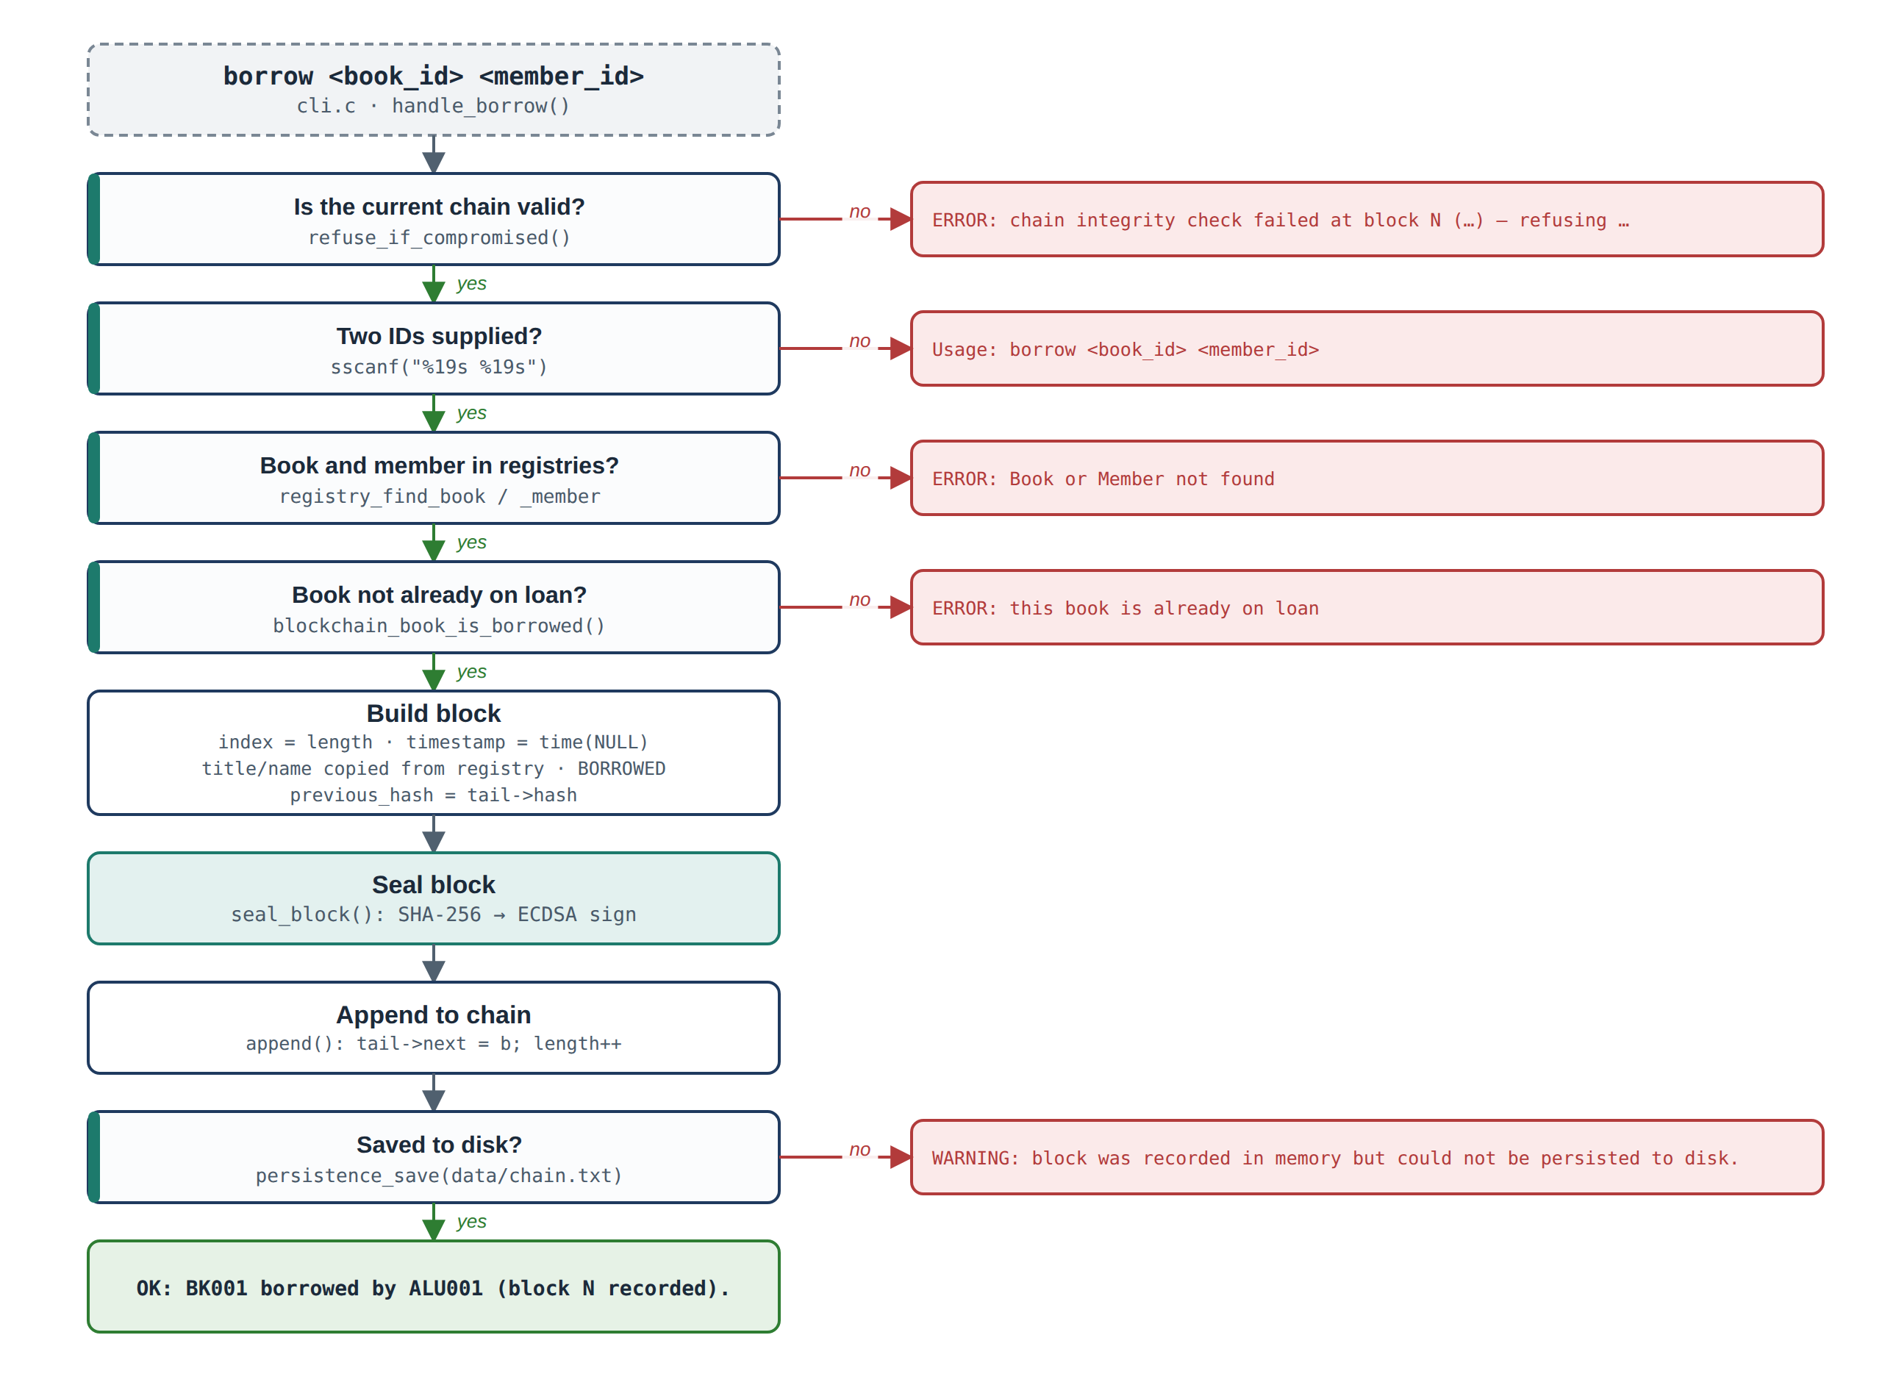
Figure 2. Borrow flow, showing the exact message printed on each failure
Linking. Before a new block is hashed, its previous_hash is copied from the current tail's hash. Because previous_hash is one of the hashed fields, each block's hash depends on the hash of the block before it, and so on back to the genesis block. Figure 3 shows a real three-block chain produced by the program.
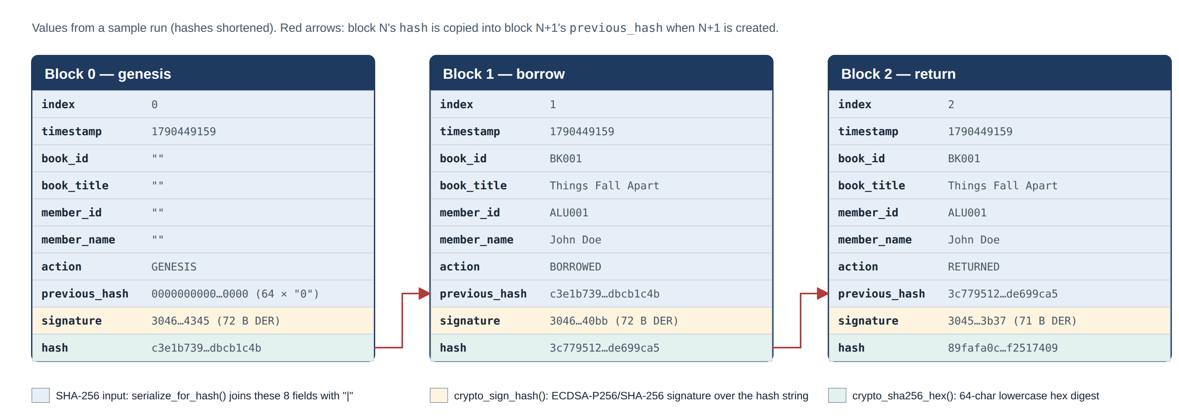
Figure 3. Block structure and chain linkage (values from a sample run, hashes shortened)
If block N is edited on disk, its recomputed hash no longer matches its stored hash. If the attacker also replaces the stored hash, block N+1's previous_hash no longer matches. If they go on to rewrite every later hash, every one of those blocks fails its ECDSA check unless they also hold the private key.

4 Registry Management
registry_load() is called first in main() with data/books.txt and data/members.txt. Nothing else runs until both files have loaded. The Book (book_id[20], title[80], author[50]) and Member (member_id[20], full_name[50], course_code[10]) structs are identical to the brief. The repository ships the brief's sample data: BK001–BK003 and ALU001–ALU003.

4.1 Book and Member Registries
Both files use the same parsing code. Each line is read with fgets() into a 256-byte buffer, trailing \r and \n characters are removed, and blank lines are skipped. split_fields() splits the line on commas into at most three fields: book_id,title,author or member_id,full_name,course_code. A line without exactly three fields, or with a field too long for its buffer, is skipped with a WARNING and the other lines still load. Accepted fields are copied with bounded snprintf(), up to 256 entries per registry. The member file is only read after at least one valid book has loaded. registry_find_book() and registry_find_member() search linearly with an exact, case-sensitive strcmp and return NULL if nothing matches.

4.2 Registry Validation
Table 3. Registry validation outcomes (output captured from the compiled program)
Situation | Program output (exact) | Outcome
books.txt / members.txt missing | ERROR: Book registry file 'data/books.txt' not found or could not be opened.  FATAL: could not load registries. Exiting. | Exit code 1
File empty / no valid lines | ERROR: Member registry 'data/members.txt' is empty or contains no valid records. + FATAL | Exit code 1
Malformed or oversized line | WARNING: malformed line in … / WARNING: field too long in … | Line skipped
Unknown book or member ID | ERROR: Book or Member not found | No block created

return takes only a book_id, so it checks only the book registry. The member is copied from the matching BORROWED block.

5 Security Mechanisms
All cryptography uses the OpenSSL 3 `libcrypto` EVP interface (linked with -lcrypto), and every OpenSSL call is kept in crypto.c. No deprecated low-level functions such as SHA256_Init are used.
Table 4. Cryptographic primitives
Purpose | Algorithm | OpenSSL API | Wrapper
Block hash | SHA-256 | EVP_Digest(…, EVP_sha256()) | crypto_sha256_hex()
Key generation | EC, NIST P-256 | EVP_EC_gen("P-256") | generate_and_save_keypair()
Key storage / load | PEM files | PEM_write_PrivateKey, PEM_write_PUBKEY, PEM_read_* | crypto_load_or_create_keypair(), crypto_load_public_key()
Sign / verify | ECDSA with SHA-256 | EVP_DigestSign, EVP_DigestVerify | crypto_sign_hash(), crypto_verify_hash()

5.1 SHA-256 Hashing and Hash Linking
serialize_for_hash() joins eight fields, in a fixed order and separated by |, into one text buffer. Only signature and hash itself are left out. For block 1 of the sample run the hashed text is 1|1790449159|BK001|Things Fall Apart|ALU001|John Doe|BORROWED|c3e1b739…1c4b.
src/blockchain.c — serialize_for_hash()
snprintf(buf, buf_len, "%d|%ld|%s|%s|%s|%s|%s|%s",
b->index, (long)b->timestamp, b->book_id, b->book_title,
b->member_id, b->member_name, b->action, b->previous_hash);

crypto_sha256_hex() passes this buffer to EVP_Digest once, when the block is sealed, and stores the 32-byte result as 64 lowercase hex characters in hash. If hashing fails it stores an empty string, which seal_block() treats as an error. During validation the same two functions recompute the hash of every loaded block and compare it with the stored value. A mismatch means one of the eight fields changed. previous_hash is the only thing that ties one block to the next: block 0 holds 64 zeros, and every later block holds the hash of the block before it (Figure 3).

5.2 Digital Signatures and Key Management
Keys. main() calls crypto_load_or_create_keypair("keys/private.pem", "keys/public.pem"). If both files exist, the private key is loaded. Otherwise a new P-256 key pair is generated with EVP_EC_gen and written as PEM files. The private-key file is set to owner-only access with chmod(…, S_IRUSR | S_IWUSR) (mode 0600) before any key material is written to it. A test run produced -rw------- private.pem and -rw-r--r-- public.pem. The public key is then loaded again, separately, with crypto_load_public_key(), so signing uses priv_key and all verification uses only the key stored in public.pem. .gitignore excludes /keys/*.pem, and no key material is embedded in the source or printed.
Signing. Inside seal_block(), straight after hashing, the block's 64-character hex hash string is signed with EVP_DigestSign using SHA-256, giving a DER signature of 70–72 bytes. A first call with a NULL buffer asks OpenSSL for the signature length, and anything longer than the 72-byte field is refused:
src/crypto.c — crypto_sign_hash() (return-value checks omitted)
EVP_DigestSignInit(ctx, NULL, EVP_sha256(), NULL, pkey);
EVP_DigestSign(ctx, NULL, &needed_len, (const unsigned char *)hash_hex, strlen(hash_hex));
if (needed_len > sig_out_cap) { /* "signature ... does not fit" */ goto done; }
EVP_DigestSign(ctx, sig_out, &sig_len, (const unsigned char *)hash_hex, strlen(hash_hex));

Verification. crypto_verify_hash() treats only an EVP_DigestVerify result of exactly 1 as valid (valid = (rc == 1)), so both a mismatch and an internal error count as invalid. A failed verification makes blockchain_validate() report ECDSA signature is invalid for this block's hash. The automated tests show the signature check works independently of the hash check: a signature with one hex digit changed is caught as a signature failure, and so is a chain checked against the wrong public key.
What a signature proves. A valid signature shows that the block's data was sealed by whoever held keys/private.pem at the time, which in practice means this installation of the program. It does not identify an individual librarian.

5.3 Security Limitations
- One locally stored key. The private key is an unencrypted PEM file on the same machine as the chain, protected only by file permissions. Anyone who can read it can rewrite and re-sign the whole chain so that it still validates.
- No user authentication or access control. There is no login, no per-user key and no role check. Anyone who can run the program can record transactions.
- Deleting the newest blocks is not detected. Blocks only link backwards, and nothing outside the file records the latest hash or the chain length. Removing the last line of data/chain.txt was tested: the program reported Loaded chain: 3 block(s), integrity verified. Deleting the file entirely makes the program start a new chain.
- Local, not distributed. There are no other nodes, no replicated copies and no consensus. The chain is tamper-evident, not tamper-proof. Saves are also not atomic: the file is rewritten in place with fopen("w").
A production system would need per-user keys held in secure hardware, access rules, replicated or externally anchored chain heads (to detect deleted blocks), and atomic writes.

6 Data Persistence
The chain is stored in `data/chain.txt`, a plain-text file with one line per block and ten fields separated by |. No binary chain.bin file is used. The field order is index|timestamp|book_id|book_title|member_id|member_name|action|previous_hash|signature_hex|hash:
data/chain.txt from a test run (hex values shortened)
0|1790449159|||||GENESIS|0000…0000|3046022100acb9…54345|c3e1b739…1c4b
1|1790449159|BK001|Things Fall Apart|ALU001|John Doe|BORROWED|c3e1b739…1c4b|30460221…40bb|3c779512…9ca5
2|1790449159|BK001|Things Fall Apart|ALU001|John Doe|RETURNED|3c779512…9ca5|30450220…3b37|89fafa0c…7409

Why text instead of binary. Writing raw structs to disk would depend on the compiler's padding, byte order and time_t size, and would save a meaningless next pointer. A text file avoids all of that and can be edited in any text editor, which is exactly what the tamper demonstration needs. Signature bytes are stored as hex.
Saving. persistence_save() opens the file in "w" mode and writes one fprintf line per block. It runs after the genesis block is created and after every successful borrow or return, so the file is always up to date even if the program is killed. If the file cannot be written, the program prints WARNING: block was recorded in memory but could not be persisted to disk.
Loading. persistence_load() rebuilds one block per line. parse_line() checks that each line has exactly 10 fields, that index and timestamp parse as integers (using strtol with errno and end-pointer checks), that every field fits its buffer, and that the signature is valid hex. sig_len is rebuilt from the decoded signature length. If any line fails, the result is PERSIST_CORRUPT and main() exits. The loader deliberately does not check hashes or signatures. main() calls blockchain_validate() straight after loading, so all cryptographic checks happen in one place (Figure 4).
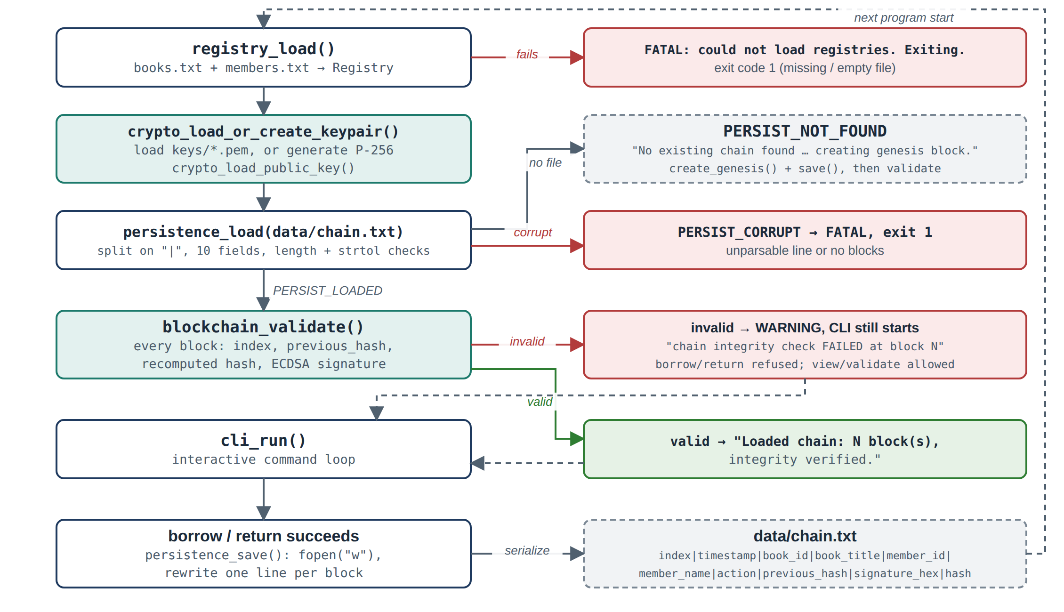
Figure 4. Start-up sequence and persistence lifecycle (main.c)

7 Core Operations, Validation and Tamper Detection

7.1 Borrow, Return and View Records
Borrow (borrow <book_id> <member_id>) follows Figure 2: integrity check, argument parsing with bounded sscanf("%19s %19s"), registry lookup, a loan-state check, block creation, sealing, append and save. It ends with OK: BK001 borrowed by ALU001 (block 1 recorded).
Return (return <book_id>). find_last_for_book() walks the whole chain, skips the genesis block, and keeps the last block with a matching book_id, which is the book's most recent lending event. If there is no such block, or its action is not BORROWED, the book is not on loan and the program prints ERROR: this book was never borrowed, or has already been returned. Otherwise a RETURNED block is created with the book and member details copied from that BORROWED block, then sealed, appended and saved. Loan status is never stored separately; it is always worked out from the chain.
View records (view records / view). print_records() prints every block with its action, book ID and title, member ID and name, the local time (localtime_r and strftime("%Y-%m-%d %H:%M:%S")), hash, previous hash, and signature=VALID or signature=INVALID from crypto_verify_hash().
Table 5. CLI commands (cli.c → cli_run(); matched case-insensitively)
Command | Handler | Result
borrow <book_id> <member_id> | handle_borrow() | OK: … borrowed by … (block N recorded). or an error
return <book_id> | handle_return() | OK: … returned (block N recorded). or an error
view records / view | print_records() | All blocks with fields, hashes and signature status
validate chain / validate / chain status | print_status() | Chain status: N block(s), VALID or COMPROMISED + first bad index and reason
list books / list members | cli_run() | Registry contents
help, exit / quit | print_help(), loop exit | Command list; quit
anything else | — | Unrecognized command: '…'. Type 'help' for the command list.

7.2 Chain Validation
blockchain_validate() walks the chain once and returns { valid, bad_index, reason } for the first failure it finds. An empty chain is invalid. expected_prev_hash starts as 64 zeros and expected_index as 0. Each block is then checked in the order shown in Table 6.
Table 6. Checks applied to every block, in order (blockchain.c → blockchain_validate())
# | Check | Comparison | Reason reported on failure
0 | Index order | b->index vs expected_index | block index out of sequence
1 | Link | b->previous_hash vs expected_prev_hash: 64 zeros for block 0, otherwise the previous block's hash | previous_hash does not match the prior block's hash
2 | Hash integrity | Stored b->hash vs SHA-256 recomputed from serialize_for_hash(b) | stored hash does not match recomputed hash (block data was modified)
3 | Signature | crypto_verify_hash(pub_key, b->hash, b->signature, b->sig_len) | ECDSA signature is invalid for this block's hash

src/blockchain.c — blockchain_validate() (abridged)
for (const Block *b = chain->head; b; b = b->next) {
if (b->index != expected_index) { /* fail: index */ }
if (strcmp(b->previous_hash, expected_prev_hash) != 0) { /* fail: link */ }
serialize_for_hash(b, buf, sizeof(buf));
crypto_sha256_hex((const unsigned char *)buf, strlen(buf), recomputed);
if (strcmp(recomputed, b->hash) != 0) { /* fail: hash */ }
if (!crypto_verify_hash(pub_key, b->hash, b->signature, b->sig_len))
{ /* fail: sig */ }
snprintf(expected_prev_hash, HASH_HEX_LEN, "%s", b->hash);
expected_index++;
}

Check 1 compares against the previous block's stored hash. This is safe because that block has already passed Check 2. Validation runs in three places: at start-up, on request, and inside refuse_if_compromised() before every write.

7.3 Tamper Demonstration
The following was run against the compiled program in a separate test directory:
- Valid chain. After borrow BK001 ALU001 and return BK001, validate chain printed Chain status: 3 block(s), VALID.
- Past block edited. In data/chain.txt, block 1's title was changed from Things Fall Apart to Xhings Fall Apart, a single byte. The stored hash was left as it was.
- Hash no longer matches. The stored hash 3c779512…9ca5 was computed from the original title, so the recomputed hash is different.
- Detected at start-up. On restart the program printed WARNING: chain integrity check FAILED at block 1: stored hash does not match recomputed hash (block data was modified).
- Reported and blocked. validate chain printed Chain status: 3 block(s), COMPROMISED and first problem at block index 1: …. A following borrow BK002 ALU002 was refused with ERROR: chain integrity check failed at block 1 (…) — refusing to add new records until this is resolved.
Figures 12 and 13 in section 10 show the same demonstration run on the author's machine. The hash values differ from the ones above because the blocks have different timestamps, but the program output is the same.
Refusing new writes matters. Without it, a new block would link to the tampered block's stored hash and be signed correctly, which would make the damaged history harder to spot. tests/run_tests.sh also automates tampering with the stored hash, with previous_hash, with a single byte, with a signature, and with the public key.

8 Error Handling and Data Validation
Errors fall into three levels. Fatal at start-up (exit code 1): the registries, keys or chain file cannot be used. Flagged, not fatal: the chain file parses but fails validation, so the CLI starts and view/validate work, but writes are refused. Per command: the program prints a message and keeps running.
Table 7. Error scenarios handled by the program
Error scenario | Detected in | Program response
Registry file missing or empty | registry.c → registry_load() | ERROR: … then FATAL: could not load registries. Exiting.
Malformed or oversized registry line | registry.c → split_fields(), length checks | WARNING: …; line skipped
Unknown book or member ID | blockchain_borrow() / blockchain_return() | ERROR: Book or Member not found
Book already on loan | blockchain_book_is_borrowed() | ERROR: this book is already on loan
Return of a book not on loan | find_last_for_book() | ERROR: this book was never borrowed, or has already been returned
Missing arguments / unknown command | cli.c → sscanf count, cli_run() | Usage: … / Unrecognized command: …
Chain file unparsable or empty | persistence.c → parse_line(), persistence_load() | ERROR: chain file … unparsable … then FATAL, exit 1
Tampered chain (index, link, hash, signature) | blockchain_validate() | Start-up WARNING; COMPROMISED with block index and reason; writes refused
Key generation or load failure | crypto_load_or_create_keypair(), crypto_load_public_key() | ERROR: with the OpenSSL error string, then FATAL, exit 1
Hashing or signing failure; signature > 72 bytes | seal_block(), crypto_sign_hash() | Block freed; ERROR: internal cryptographic operation failed
Chain file cannot be written | persistence_save() | WARNING: block was recorded in memory but could not be persisted to disk.
Out of memory | calloc checks | Error returned; nothing appended

Defensive C. All copies into fixed-size fields use snprintf. User input is read with bounded %19s conversions, numbers are parsed with checked strtol rather than atoi, and hex decoding is bounds-checked. Every block and OpenSSL object is freed exactly once. The code compiles with -std=c11 -Wall -Wextra -Wpedantic with zero warnings.

9 Testing and Results
There are two sources of evidence. The first is tests/run_tests.sh (make test), which runs the compiled program in a fresh temporary directory for each test. The second is a manual session against the compiled program. Both were run on 26 September 2026 with gcc 13.3.0 and OpenSSL 3.0.13 on Linux, and the automated suite reported 44 passed, 0 failed.
Table 8. Automated test suite (tests/run_tests.sh): 44/44 assertions passed
Group | Assertions | Coverage
Registry | 11 | Valid load; missing or empty books/members file; malformed line; oversized field
Borrow / Return | 5 / 4 | Valid borrow and return; invalid book or member; double borrow; never borrowed; already returned
Blockchain | 9 | Genesis created only once; 4-block chain; reload in a new process; titles and names from the registry; corrupted genesis; duplicate index
Cryptography | 5 | All signatures valid; corrupted signature; wrong public key
Tampering | 7 | Edited field, stored hash or previous_hash; single-byte flip; write refused
Memory safety | 3 | Full session under AddressSanitizer/UBSan: no errors or leaks

Table 9. Required demonstrations: manual session and automated results
# | Test case | Input / action | Actual result (program output) | Status
T1 | Registry loading | start; list books; list members | Books (3): … Members (3): | PASS
T2 | Missing registry | remove books.txt, start | ERROR: Book registry file … not found …, FATAL, exit 1 | PASS
T3 | Valid borrow | borrow BK001 ALU001 | OK: BK001 borrowed by ALU001 (block 1 recorded). | PASS
T4 | Invalid book / member ID | borrow ZZZ ALU001; borrow BK002 ALU999 | ERROR: Book or Member not found (both) | PASS
T5 | Double borrow | borrow BK001 ALU002 | ERROR: this book is already on loan | PASS
T6 | Return / invalid return | return BK001 (twice); return BK003 | OK: BK001 returned (block 2 recorded)., then … never borrowed, or has already been returned (×2) | PASS
T7 | View records | view records | 3 blocks, each signature=VALID | PASS
T8 | Valid chain | validate chain | Chain status: 3 block(s), VALID | PASS
T9 | Tampered chain | edit block 1 title; restart; validate chain | WARNING … at start-up; COMPROMISED, first problem at block index 1 | PASS
T10 | Write on tampered chain | borrow BK002 ALU002 | ERROR: chain integrity check failed … refusing to add new records … | PASS
T11 | Persistence | exit and restart | Loaded chain: 2 block(s), integrity verified. (automated test) | PASS
T12 | Delete newest block | remove the last line of chain.txt | Loaded chain: 3 block(s), integrity verified.: not detected | Gap (5.3)

10 Screenshots of Application Execution
Screenshots were taken after a clean build (make clean && make), with data/chain.txt and keys/*.pem removed first so the first-run behaviour is visible. Each figure caption names the requirement it demonstrates.
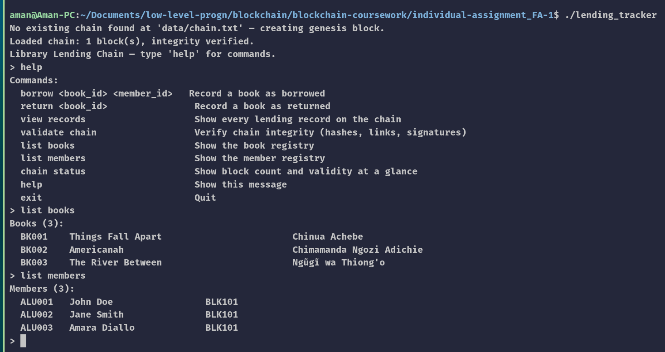
Figure 5. Program start-up: registries loaded and genesis block created
Shows a genesis block (index 0) created and verified on the first run, the command list from help, and both registries loaded into memory at start-up.
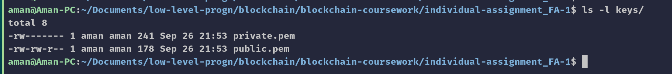
Figure 6. Generated ECDSA key pair, with owner-only permissions on the private key
Shows that a persistent P-256 key pair is stored outside the source code and that private.pem is readable only by its owner (-rw-------).
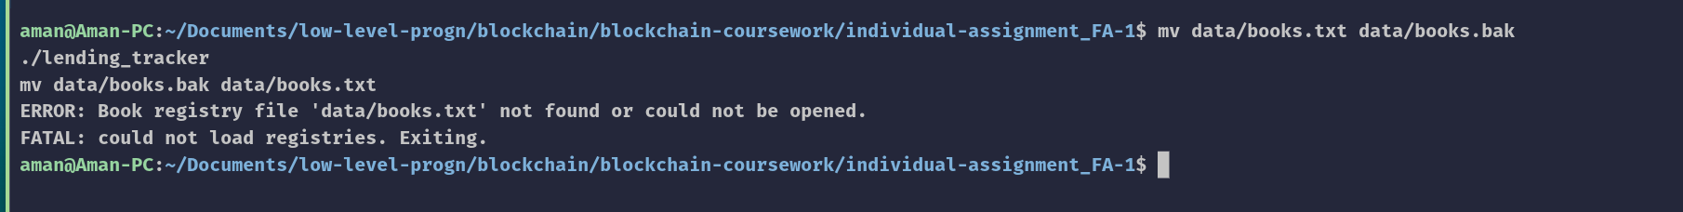
Figure 7. Error when books.txt is missing
Shows the required error message and clean exit when a registry file cannot be found.
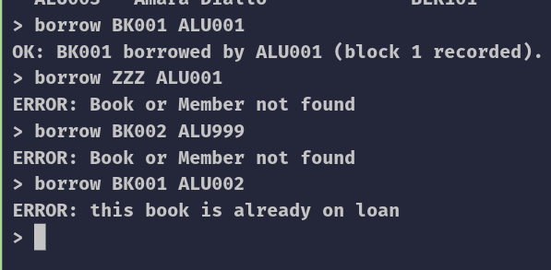
Figure 8. Valid borrow; rejected invalid book ID, invalid member ID and double borrow
Shows that book and member IDs are checked against the registries before any block is created and that a book cannot be borrowed twice.
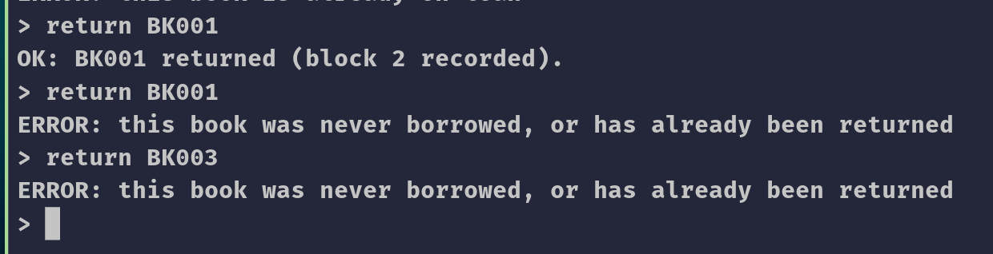
Figure 9. Successful return and rejected invalid returns
Shows that a return is only recorded when the book's most recent record is BORROWED.
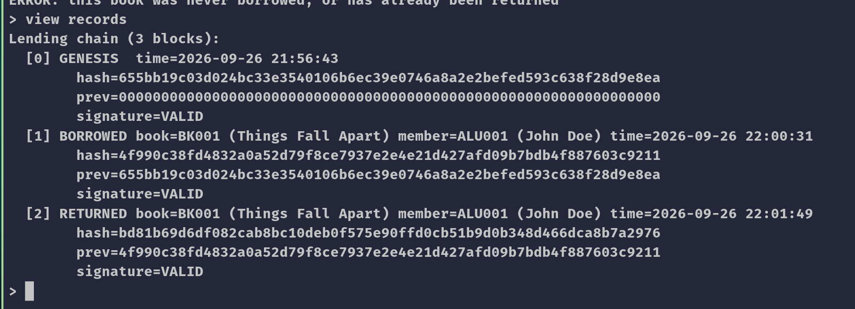
Figure 10. Lending history with hashes, previous hashes and signature status
Shows all records with title, member name, action, timestamp and signature validity, and each block's prev equal to the previous block's hash.
Figure 11. validate chain on an unmodified chain
Shows the chain passing all four validation checks before any tampering.
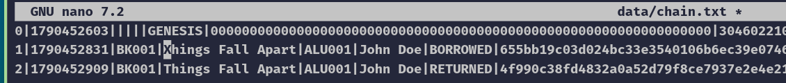
Figure 12. A past block edited outside the program
Shows a single-character change to a historical record made directly in the chain file.
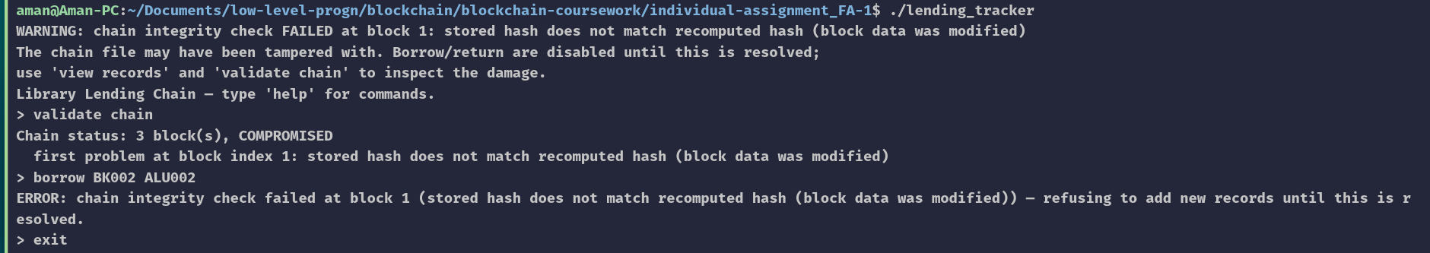
Figure 13. Start-up warning, COMPROMISED status and refused write after tampering
Shows that the edit is detected, traced to block 1 with its reason, and that no new records are accepted until it is resolved.

11 Challenges Encountered and Solutions
These challenges are recorded in the repository: in code comments, the Makefile, docs/ARCHITECTURE.md, docs/REQUIREMENTS.md and docs/REPORT.md. The git history keeps only the final source files, so the "before" state is taken from that documentation.

11.1 Variable-length signatures in a fixed-size field
Challenge: The brief defines unsigned char signature[72] with no length field. Cause: DER-encoded P-256 ECDSA signatures vary between 70 and 72 bytes, and verification needs the exact length.
Solution: An in-memory-only field, size_t sig_len, was added, and crypto_sign_hash() checks the size before writing. On load, the length is rebuilt from the hex string by crypto_hex_to_bytes() (comment in blockchain.h; REQUIREMENTS.md ambiguity 4). Result: The brief's ten fields are unchanged, and 71- and 72-byte signatures both verify after a save and reload.

11.2 Choosing a persistence format
Challenge: The chain has to survive restarts and be easy to edit externally for the tamper demonstration. Cause: Writing raw structs to disk depends on padding, byte order and time_t size, saves a meaningless next pointer, and needs a hex editor to modify.
Solution: A |-delimited text format with hex signatures was chosen. The loader checks only the file's structure and leaves cryptographic checks to blockchain_validate() (ARCHITECTURE.md, "Persistence strategy"). Result: The file is portable and editable in any text editor, malformed files are rejected cleanly, and all tamper detection happens in one function.

11.3 Showing tamper detection without weakening security
Challenge: The program has to start on a tampered chain so validate chain can show the failure, but it must not keep accepting records. Cause: According to docs/REPORT.md §18, an earlier version exited on any validation failure at start-up, which made a live demo impossible. Simply starting anyway would let a correctly signed new block be added on top of the tampered history.
Solution: A failed start-up validation became a warning instead of a fatal error, and refuse_if_compromised() re-validates the chain before every write (comments in main.c and cli.c). Result: Tampering can be inspected, but no writes are accepted; the test "borrow is refused while the chain is compromised" passes.

11.4 POSIX functions under strict C11
Challenge: localtime_r() is not declared when compiling with -std=c11. Cause: In strict ISO C mode, glibc hides POSIX extensions unless a feature-test macro is defined.
Solution: -D_POSIX_C_SOURCE=200809L was added to CFLAGS in the Makefile. Result: The code builds with -Wall -Wextra -Wpedantic and produces no warnings.

11.5 Unsafe string copy found during review
Challenge: A strcpy was found in the validation loop, against the project's rule of using only bounded string functions. Cause: Both buffers were the same size, so the compiler gave no warning.
Solution: A git grep for unsafe functions found it, and it was replaced with snprintf (REQUIREMENTS.md R11.2). Result: The source contains no strcpy, strcat or gets, and the sanitizer test session is clean.

12 Discussion
The project demonstrates the core data structure behind a blockchain: an ordered, append-only list anchored by a genesis block, in which each record commits to the one before it through a SHA-256 hash, and in which loan status is always worked out from the chain's own history. Integrity is enforced, not just recorded: every hash is recomputed on every start-up and before every write, and the tests show that each of the four checks catches its own kind of tampering. ECDSA adds something hashing alone cannot provide, because anyone can recompute a SHA-256 hash but only the holder of the private key can produce a valid signature. The tests with a corrupted signature and with the wrong public key confirm that verification really distinguishes valid from invalid signatures.
The limits are just as real. With one node and one installation-wide key, and no consensus or replication, this is not comparable to Bitcoin or Ethereum. Anyone with the private key can rewrite history, and deleting the newest blocks goes unnoticed. What the project shows, working and tested, is the tamper-evidence property of a single ledger.

13 Conclusion
This project implemented a library lending tracker in C that records every borrow and return as a block in a linked-list blockchain. Book and member IDs from books.txt and members.txt are checked before any record is created. Each block is hashed with SHA-256 over its data and its predecessor's hash, then signed with a persistent ECDSA P-256 key through OpenSSL 3. The chain is saved to a text file after every change and fully re-validated at every start-up, checking index order, hash links, recomputed hashes and signatures, and naming the first block that fails. Editing a past record is detected and blocks further writes, as shown both manually and by 44 passing automated tests. The course objectives on blockchain structure, SHA-256 integrity, persistence and error handling are met. Authentication is achieved through block signatures made with the system's key. User-level authentication and access control are not implemented, and are the main area for further work.

14 References
[1] African Leadership University (2026). Individual Assignment 1: Design and Implementation of a Blockchain-Based Library Book Lending Tracker. Introduction to Blockchain Development, September 2026 Term.
[2] National Institute of Standards and Technology (2015). FIPS 180-4: Secure Hash Standard. https://doi.org/10.6028/NIST.FIPS.180-4
[3] National Institute of Standards and Technology (2023). FIPS 186-5: Digital Signature Standard. https://doi.org/10.6028/NIST.FIPS.186-5
[4] National Institute of Standards and Technology (2023). SP 800-186: Elliptic Curve Domain Parameters (defines P-256). https://doi.org/10.6028/NIST.SP.800-186
[5] OpenSSL Project. OpenSSL 3.0 manual pages: EVP_DigestSignInit(3), EVP_DigestVerifyInit(3), EVP_DigestInit(3), EVP_PKEY-EC(7), PEM_read_bio_PrivateKey(3). https://docs.openssl.org/3.0/

Appendix A — Selected Code
The main text already shows seal_block() (3.3), serialize_for_hash() (5.1), crypto_sign_hash() (5.2) and the blockchain_validate() loop (7.2). This appendix adds block creation, persistence and the integrity check that runs before every write.
A.1 src/blockchain.c — blockchain_borrow()
LendResult blockchain_borrow(Blockchain *chain, const Registry *reg, EVP_PKEY *pkey,
const char *book_id, const char *member_id) {
const Book *book = registry_find_book(reg, book_id);
const Member *member = registry_find_member(reg, member_id);
if (!book || !member) {
return !book ? LEND_ERR_BOOK_NOT_FOUND : LEND_ERR_MEMBER_NOT_FOUND;
}
if (blockchain_book_is_borrowed(chain, book_id)) return LEND_ERR_ALREADY_BORROWED;

Block *b = calloc(1, sizeof(Block));
if (!b) return LEND_ERR_CRYPTO;
b->index = (int)chain->length;
b->timestamp = time(NULL);
snprintf(b->book_id, BOOK_ID_LEN, "%s", book->book_id);
snprintf(b->book_title, BOOK_TITLE_LEN, "%s", book->title);
snprintf(b->member_id, MEMBER_ID_LEN, "%s", member->member_id);
snprintf(b->member_name, MEMBER_NAME_LEN, "%s", member->full_name);
snprintf(b->action, ACTION_LEN, "BORROWED");
snprintf(b->previous_hash, HASH_HEX_LEN, "%s", chain->tail->hash);

if (!seal_block(b, pkey)) { free(b); return LEND_ERR_CRYPTO; }
append(chain, b);
return LEND_OK;
}

A.2 src/persistence.c — persistence_save()
int persistence_save(const Blockchain *chain, const char *path) {
FILE *f = fopen(path, "w");
if (!f) { fprintf(stderr, "ERROR: could not open '%s' for writing the chain.\n", path); return 0; }
for (const Block *b = chain->head; b; b = b->next) {
char sig_hex[MAX_SIGNATURE_LEN * 2 + 1];
crypto_bytes_to_hex(b->signature, b->sig_len, sig_hex, sizeof(sig_hex));
fprintf(f, "%d|%ld|%s|%s|%s|%s|%s|%s|%s|%s\n", b->index, (long)b->timestamp,
b->book_id, b->book_title, b->member_id, b->member_name,
b->action, b->previous_hash, sig_hex, b->hash);
}
fclose(f);
return 1;
}

A.3 src/cli.c — refuse_if_compromised()
static int refuse_if_compromised(const Blockchain *chain, EVP_PKEY *pub_key) {
ChainValidation v = blockchain_validate(chain, pub_key);
if (!v.valid) {
printf("ERROR: chain integrity check failed at block %d (%s) — refusing to add new records "
"until this is resolved.\n", v.bad_index, v.reason);
return 1;
}
return 0;
}

Appendix B — Implementation Traceability
Table 10. Feature-to-code traceability
Feature | File | Function / structure | Section
Block, chain | blockchain.h/.c | struct Block, Blockchain, append() | 3.1
Genesis | blockchain.c | blockchain_create_genesis(), blockchain_zero_hash() | 3.2
Registries | registry.h/.c | Book, Member, registry_load(), registry_find_*() | 4
Borrow / Return | cli.c, blockchain.c | handle_borrow/return(), blockchain_borrow/return(), find_last_for_book() | 3.3, 7.1
SHA-256 | blockchain.c, crypto.c | serialize_for_hash(), crypto_sha256_hex(), seal_block() | 5.1
ECDSA and keys | crypto.c | crypto_load_or_create_keypair(), crypto_sign_hash(), crypto_verify_hash() | 5.2
Validation | blockchain.c, cli.c | blockchain_validate(), refuse_if_compromised() | 7.2, 7.3
Persistence | persistence.c | persistence_save(), persistence_load(), parse_line() | 6
Start-up, CLI | main.c, cli.c | main(), cli_run(), print_records(), print_status() | 2, 7.1
Build, tests | Makefile, tests/run_tests.sh | make, make test (44 assertions), make asan | 9

